**VNC Server** **( Virtual Network Computing )**

(Linux Remote Desktop Access)

* **VNC ( Virtual Network Computing )** Servers enables remote desktop access for Linux systems similar to in windows. Generally Linux administrators doesn’t prefer to use windows access, But some times we required to have access remote desktop of Linux. In that case we need to install vnc server on our Linux system. But In most cases all you need is to SSH remotely to do your administration tasks.
* **Port No :- 5900 (default)**

**On Server Side :-**

1. To check whether the rpm "vnc-server" is installed on server system (if not then installed) # yum install vnc-server

# yum install tigervnc-server

1. Open Vncserver Config File

# cd /etc/sysconfig

# vim vncserver

1. Create Vnc Passward for root

# vncpasswd

Passward :

Varify:

***Or***

Create New User (For VNC) And Set the Vnc Passward

# useradd vncuser

# passwd vncuser

# su – vncuser

# vncpasswd

Passward :

Varify:

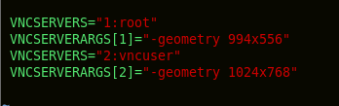

1. Restart service

# service vncserver restart

**On Linux Client Side :-**

1. For the client side we have to installed rpm "vnc"

# yum install vnc

1. Then Connect to VNC Server Using Command and Enter VNC Server IP

# vncviewer

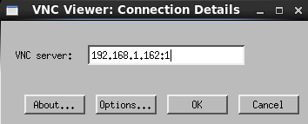 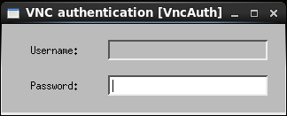

***or***

# vncviewer <IP_Address:1>



**On Windows Client Side :-**

1. For the Windows client side we have to installed VNC Viewer .exe File
2. Open Application, Type VNC Server IP_Address and hit Enter

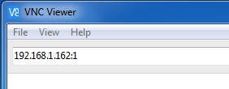 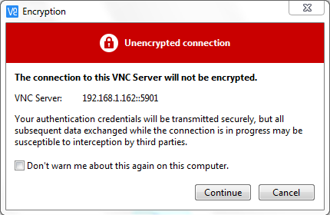

1. Enter the Passward of VNC Server And Connect to Remote Access

